**Assignment -4**

**M. Poojith Ganesh**

**192311290**

**CSA 5196- Cryptography and Network**

**Security with Quantum Computing**

**1.**

import numpy as np

def initialize_state():

"""Initialize the SHA-3 state matrix with 1600 bits (5x5 lanes of 64 bits)."""

return np.zeros((5, 5), dtype=np.uint64) # 5x5 lanes, each 64 bits

def inject_message_block(state, block_size=1024):

"""Inject a message block ensuring at least one nonzero bit per lane in 1024-bit portion."""

lanes_to_fill = block_size // 64 # Number of lanes covered by the message block

for i in range(lanes_to_fill):

x, y = divmod(i, 5) # Assign lane positions in a 5x5 matrix

state[x, y] = np.random.randint(1, 2**64, dtype=np.uint64) # Ensure nonzero bits

return state

def count_empty_lanes(state):

"""Count the lanes in the capacity portion that are still zero."""

return np.sum(state == 0) # Count lanes still at zero

def track_zero_lanes():

"""Track iterations needed until all capacity lanes have at least one nonzero bit."""

state = initialize_state()

rounds = 0

while count_empty_lanes(state) > 9: # 1600 - 1024 = 576 bits (9 lanes capacity)

state = inject_message_block(state)

rounds += 1

return rounds

# Run the tracking simulation

rounds_needed = track_zero_lanes()

print(f"All capacity lanes have at least one nonzero bit after {rounds_needed} message block injections.")

**Output:**

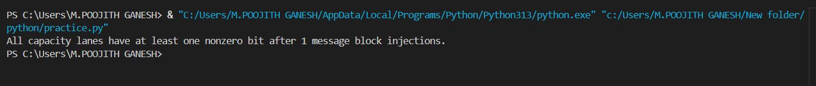

**2.**

import random

def diffie_hellman(p, g, secret_a, secret_b):

# Compute public values

A = pow(g, secret_a, p)

B = pow(g, secret_b, p)

# Compute shared secret key

shared_key_a = pow(B, secret_a, p)

shared_key_b = pow(A, secret_b, p)

return A, B, shared_key_a, shared_key_b

# Public parameters

p = 23 # Prime number

g = 5 # Generator

# Alice and Bob choose secret numbers

secret_a = random.randint(1, p-1)

secret_b = random.randint(1, p-1)

# Perform Diffie-Hellman key exchange

A, B, shared_key_a, shared_key_b = diffie_hellman(p, g, secret_a, secret_b)

print(f"Public Parameters: p={p}, g={g}")

print(f"Alice's Secret: {secret_a}")

print(f"Bob's Secret: {secret_b}")

print(f"Alice Sends: {A}")

print(f"Bob Sends: {B}")

print(f"Alice Computes Shared Key: {shared_key_a}")

print(f"Bob Computes Shared Key: {shared_key_b}")

assert shared_key_a == shared_key_b, "Shared keys do not match!"

**Output:**

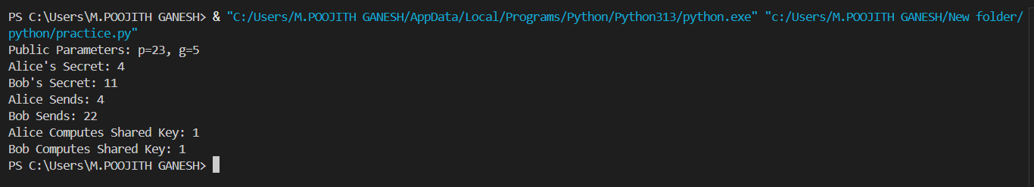

**3.**

from Crypto.Cipher import AES, DES

import binascii

def left_shift(data):

    """Left shift a byte sequence by 1 bit, handling overflow correctly."""

    num = int.from_bytes(data, 'big') << 1

    num &= (1 << (len(data) * 8)) - 1

    return num.to_bytes(len(data), 'big')

def generate_cmac_subkeys(cipher, key, block_size):

    """Generate two CMAC subkeys (K1, K2)."""

    zero_block = bytes(block_size)

    cipher_obj = cipher.new(key, cipher.MODE_ECB)

    L = cipher_obj.encrypt(zero_block)

    Rb = {16: 0x87, 8: 0x1B}[block_size]

    K1 = left_shift(L)

    if L[0] & 0x80:  # If MSB is 1, XOR with Rb

        K1 = (int.from_bytes(K1, 'big') ^ Rb).to_bytes(block_size, 'big')

    K2 = left_shift(K1)

    if K1[0] & 0x80:

        K2 = (int.from_bytes(K2, 'big') ^ Rb).to_bytes(block_size, 'big')

    return K1, K2

aes_key = b'\x2b\x7e\x15\x16\x28\xae\xd2\xa6\xab\xf7\xcf\x15\x88\x09\xcf\x4f'  # 16-byte AES key

des_key = b'\x13\x34\x57\x79\x9B\xBC\xDF\xF1'  # 8-byte DES key

K1_aes, K2_aes = generate_cmac_subkeys(AES, aes_key, 16)

print("AES CMAC Subkeys:")

print("K1:", binascii.hexlify(K1_aes))

print("K2:", binascii.hexlify(K2_aes))

K1_des, K2_des = generate_cmac_subkeys(DES, des_key, 8)

print("\nDES CMAC Subkeys:")

print("K1:", binascii.hexlify(K1_des))

print("K2:", binascii.hexlify(K2_des))

**Output:**

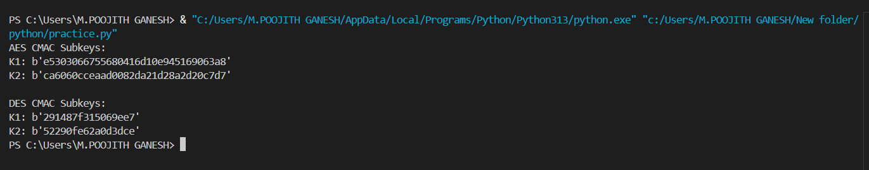

**4.**

from Crypto.Cipher import AES

from Crypto.Util.Padding import pad, unpad

from Crypto.Random import get_random_bytes

key = get_random_bytes(16)

iv = get_random_bytes(16)

block_size = 16

plaintext = b"HELLO WORLD AES!"

padded_plaintext = pad(plaintext, block_size)

ecb_cipher = AES.new(key, AES.MODE_ECB)

ecb_ciphertext = ecb_cipher.encrypt(padded_plaintext)

cbc_cipher = AES.new(key, AES.MODE_CBC, iv)

cbc_ciphertext = cbc_cipher.encrypt(padded_plaintext)

cfb_cipher = AES.new(key, AES.MODE_CFB, iv)

cfb_ciphertext = cfb_cipher.encrypt(plaintext)

ecb_decipher = AES.new(key, AES.MODE_ECB)

cbc_decipher = AES.new(key, AES.MODE_CBC, iv)

cfb_decipher = AES.new(key, AES.MODE_CFB, iv)

decrypted_ecb = unpad(ecb_decipher.decrypt(ecb_ciphertext), block_size)

decrypted_cbc = unpad(cbc_decipher.decrypt(cbc_ciphertext), block_size)

decrypted_cfb = cfb_decipher.decrypt(cfb_ciphertext)

print("ECB Ciphertext:", ecb_ciphertext.hex())

print("CBC Ciphertext:", cbc_ciphertext.hex())

print("CFB Ciphertext:", cfb_ciphertext.hex())

print("\nDecrypted ECB:", decrypted_ecb.decode())

print("Decrypted CBC:", decrypted_cbc.decode())

print("Decrypted CFB:", decrypted_cfb.decode())

**Output:**

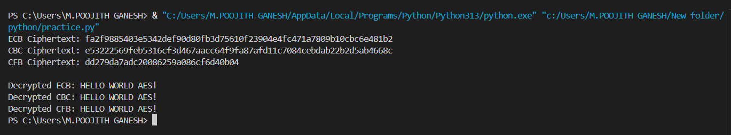

**5.**

from sympy import mod_inverse

def affine_encrypt(text, a, b):

    if gcd(a, 26) != 1:

        raise ValueError("a must be coprime with 26 for the cipher to be one-to-one.")

    cipher = ""

    for char in text.upper():

        if char.isalpha():

            p = ord(char) - ord('A')

            C = (a * p + b) % 26

            cipher += chr(C + ord('A'))

        else:

            cipher += char

    return cipher

def affine_decrypt(cipher, a, b):

    a_inv = mod_inverse(a, 26)

    plain = ""

    for char in cipher:

        if char.isalpha():

            C = ord(char) - ord('A')

            p = (a_inv * (C - b)) % 26

            plain += chr(p + ord('A'))

        else:

            plain += char

    return plain

def gcd(x, y):

    while y:

        x, y = y, x % y

    return x

a, b = 5, 8

plaintext = "HELLO WORLD"

ciphertext = affine_encrypt(plaintext, a, b)

decrypted_text = affine_decrypt(ciphertext, a, b)

print("Affine Ciphertext:", ciphertext)

print("Decrypted Text:", decrypted_text)

**Output:**

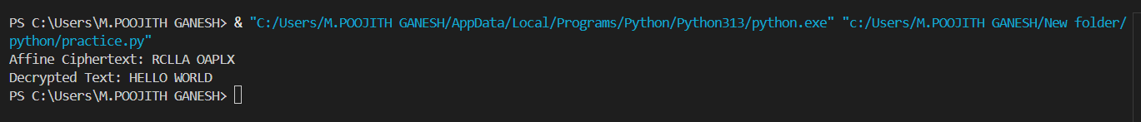

**6.**

from Crypto.Cipher import AES

from Crypto.Util.Padding import pad

import os

def xor_bytes(a, b):

    """XOR two byte sequences."""

    return bytes(x ^ y for x, y in zip(a, b))

def generate_cbc_mac(key, message, block_size=16):

    """Compute CBC-MAC of a one-block message."""

    cipher = AES.new(key, AES.MODE_CBC, iv=b'\x00' * block_size)

    padded_msg = pad(message, block_size)

    mac = cipher.encrypt(padded_msg)[-block_size:]

    return mac

key = os.urandom(16)

message = b"HELLO BLOCK!"

T = generate_cbc_mac(key, message)

new_message = message + xor_bytes(message, T)

new_mac = generate_cbc_mac(key, new_message)

print("MAC for X:", T.hex())

print("MAC for X || (X ⊕ T):", new_mac.hex())

**Output:**

